EXP 10 :
Use the following requirements for a Library Management System:
- Add a feature to search books by title and author.
- Implement an online book reservation system.
- Generate monthly reports on borrowed books for administrators.
- Enable email notifications for overdue books.
- Add support for QR code scanning for borrowing and returning books.
- Create a user-friendly dashboard for librarians.
- Allow users to review and rate books.
- Integrate a chatbot for user assistance.
- Develop a mobile app version of the system.
- Provide multi-languagesupport.

Categorize each requirement using MOSCOW Method (Must-Have, Should-Have, Could-Have, or Won’t-Have) based on the following criteria:
- Impact on the users and stakeholders.
- Feasibility considering time, budget, and resource constraints.
Finally Submit the completed Google Sheet or Excel file with all requirements categorized and justified.

Workflow:
Step 1: Open Microsoft Excel, Click Blank Workbook.

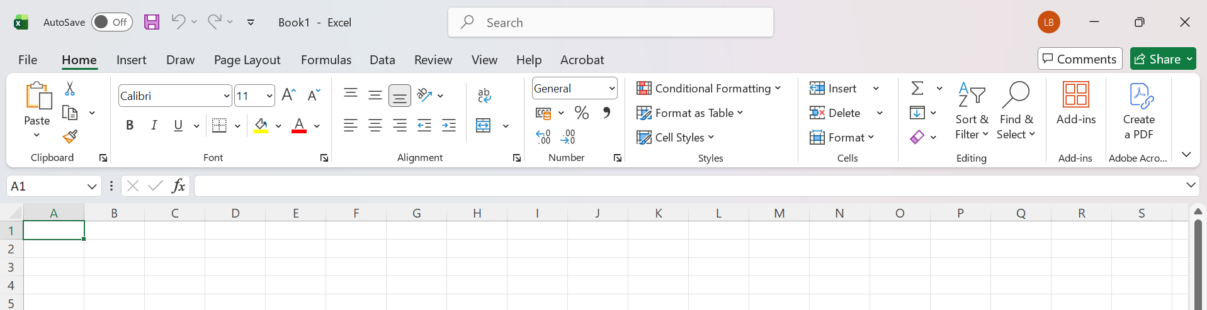

Step 2: Create the Headers
In the first row, enter:
Cell | Text
A1 | Requirement
B1 | MoSCoW Category
C1 | Justification (Impact & Feasibility)

Step 3 : Enter the Data

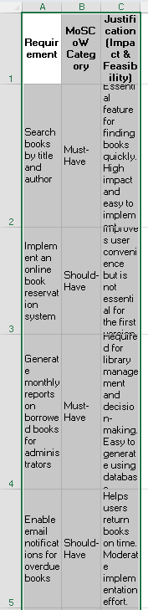

Step 4 :
Format the Table
- Select A1:C11.
- Click Home → Format as Table.
- Choose any table style.
- Click OK.

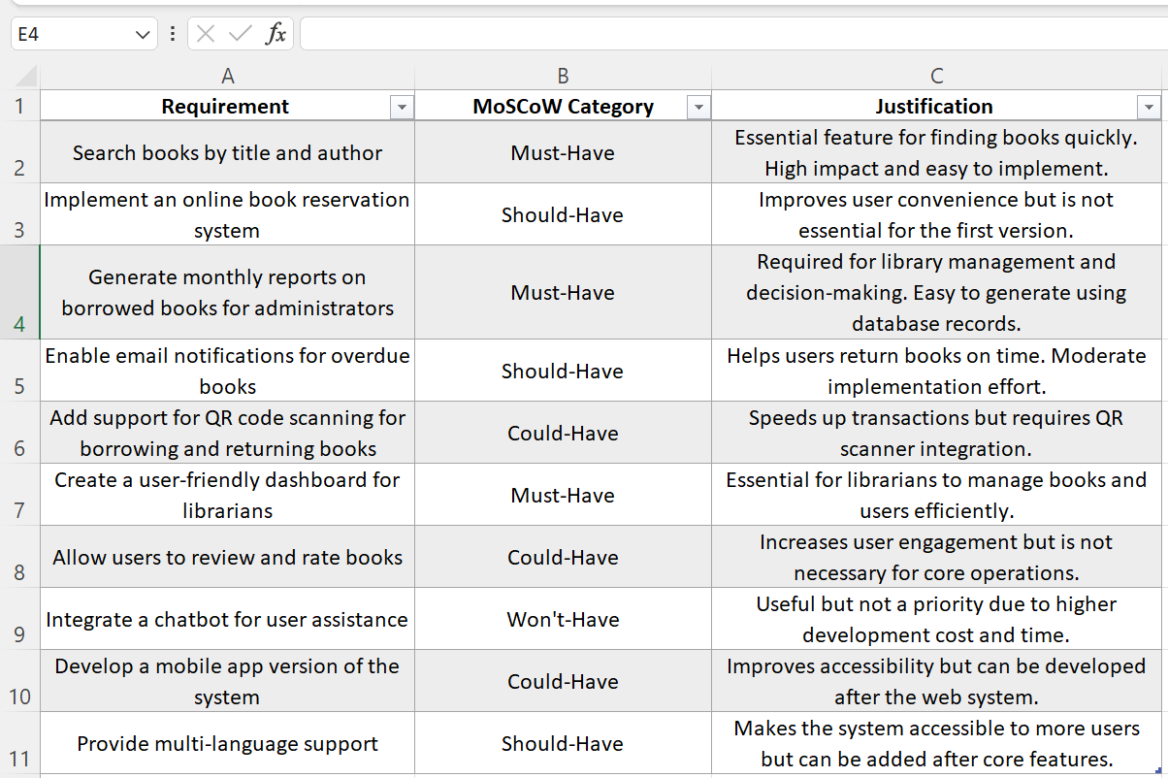

Step 5 : Save the File

Library_Management_MoSCoW.xlsx

